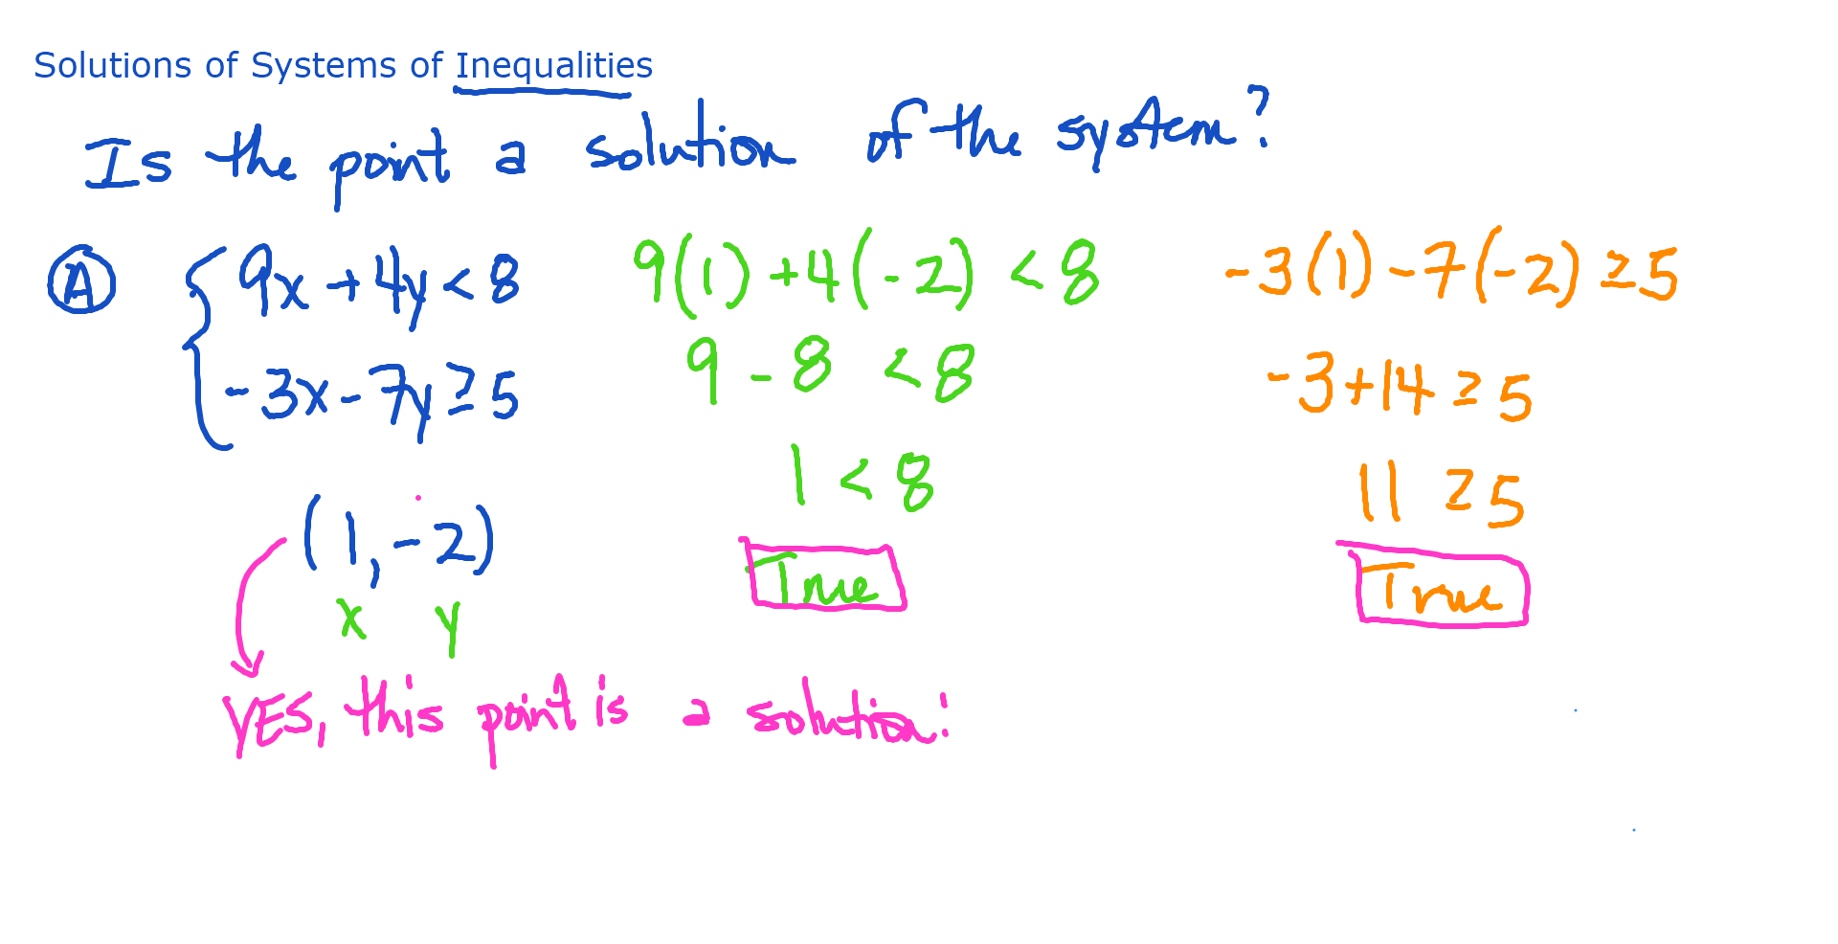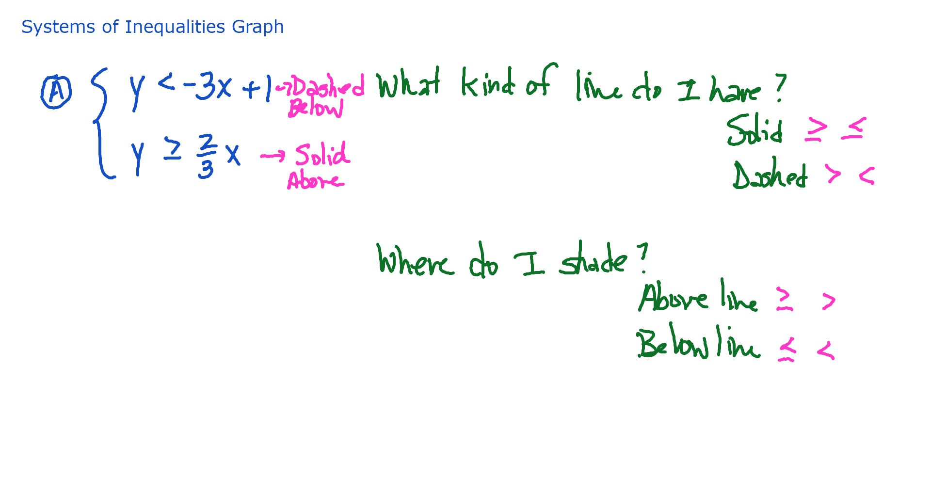

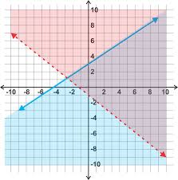
Is the point $\left(6, 2\right)$ a solution of the system?

Is the point $\left(0.-6\right)$ a solution of the system?

