Mock FRQ #5

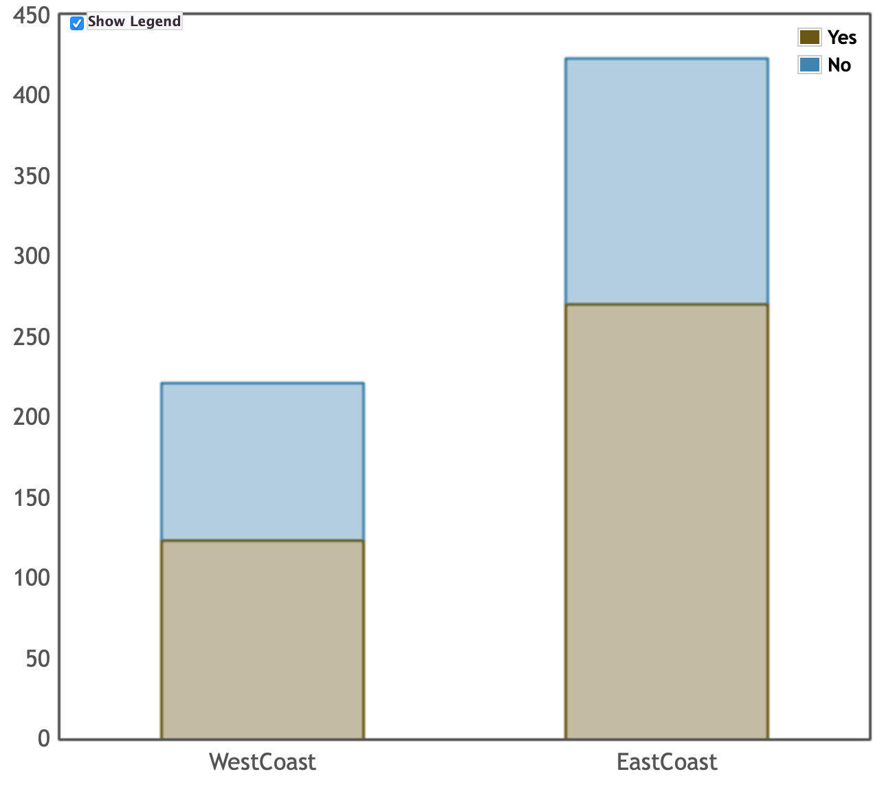
Researchers were curious if different regions of the country differed in their use of a new, popular, social media app. Two independent random samples were taken. One sample from a city on the west coast of America and another from the east coast. College students aged 18-25 were asked if they have used the app. Their responses are organized in a table and graph below.

 | West Coast | East Coast | Total
Yes | 123 | 270 | 393
No | 98 | 153 | 251
Total | 221 | 423 | 644

- Does there appear to be an association between which coast a student is from and whether or not they have used this social media app? (Note: Do not answer this question using an inference procedure.)
Yes, there is an association. It appears that East Coast students are more likely to have used the app than West Coast students. This is apparent from the graph and from the percents on the table (63.8% yes vs 55.7% yes).
- What is the probability that a randomly selected student is from the west coast, given that this student has used the social media app?
123/393 = 0.313
- A curious statistics student wants to test if the proportion of students who have used the app is greater on the East Coast than on the West Coast. Write the appropriate null and alternative hypotheses for this hypothesis test.
$H_{0}$: $p_{e}=p_{w}$; $H_{a}$: $p_{e}>p_{w}$; where $p_{e}$ = true proportion of east coast students who have used the app and $p_{w}$ = true proportion of west coast students who have used the app.
- The P-value for the hypothesis test is 0.022. Based on this p-value, what conclusion should the researcher make?
Since the p-value of 0.022 < α, we reject Ho. There is convincing evidence that the percentage of east coast students who have used this app is greater than the percentage of west coast students who have used this app.
- In another study, college students on the East Coast were compared with 85 students in the Midwest and p-value of 0.13 was found. However, there is concern that a Type II has been made. Describe how a different sample size would decrease the likelihood of a Type II error.
If the sample size(s) were larger, this would reduce the probability of a type II error. Increasing the sample size(s) would decrease the standard deviation of the sampling distribution of the sample proportions. This would increase our ability to detect a difference between the two populations.

